Use-Case Realization Report
Update Error

Issue <1.0>
Revision History
Date | Issue | Description | Author
<29/apr/11> | <1.0> | Initial Document | Koh Ming Jin

Table of Contents
1. Brief Description 4
2. Flow of Events 4
2.1 Standard Flow 4
2.2 Exception 4
3. Interaction Diagrams 4
3.1 Collaboration Diagram for Update Error 4
4. Participating Objects 4
4.1 Error 4
4.2 Error Panel 4
5. Class Diagrams 5
5.1 Domain Class Diagram: Update Error 5
6. Derived Requirements 5

Use-Case Realization Report
Update Error

Brief Description
This use case enables an operation manager to update a new error record. The required information includes the error ID, error name and error explanation.

Flow of Events
The standard flow of events for this use case and any exceptions are described in the following subsections. See section 3.1 for an overview of the participating Actors and Domain Objects.

Standard Flow
The flow of events is described as follows:

- The use case starts when Operation Manager selects the Update Error option of the system.
- The Update Error Panel is displayed.
- The Operation Manager provides all the required details concerning an existing error into the Update Error Panel.
- The existence of the error in the system is checked against the error information held by the database.
- If the error is in the current database, the error record is updated with the supplied details.
- The use case terminates.
*Note: Update includes updating and deleting error code

Exception
- The error ID does not exist. If the input error ID is not found to be an existing one, the error modification will fail. An error message is displayed, and the Update Error Screen is displayed again.

Interaction Diagrams

Collaboration Diagram for Update Error
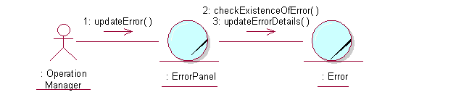

Participating Objects

Error
This object stores the details concerning the error of the COMS.

Error Panel
This screen is used for collection of error details, when a new error record is to be updated. The Director, Department Manager and Operation Manager actors use this object.

Class Diagrams

Domain Class Diagram: Update Error
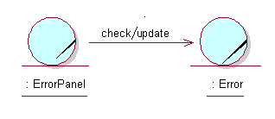

Derived Requirements
The Operation Manager PC keyboard and mouse will be used to enter error details (if any) and view all the system responses.

